CO2: Design Finite Automata (DFA, NFA, ε-NFA) and demonstrate their equivalence for recognizing regular languages. (BL:3)
P.SUDHARSHAN REDDY
192372204
CSE(AI)

Question 1 — Regular Expression for the Given Automata
Given automaton: states q0 (start), q1, q2 (final):
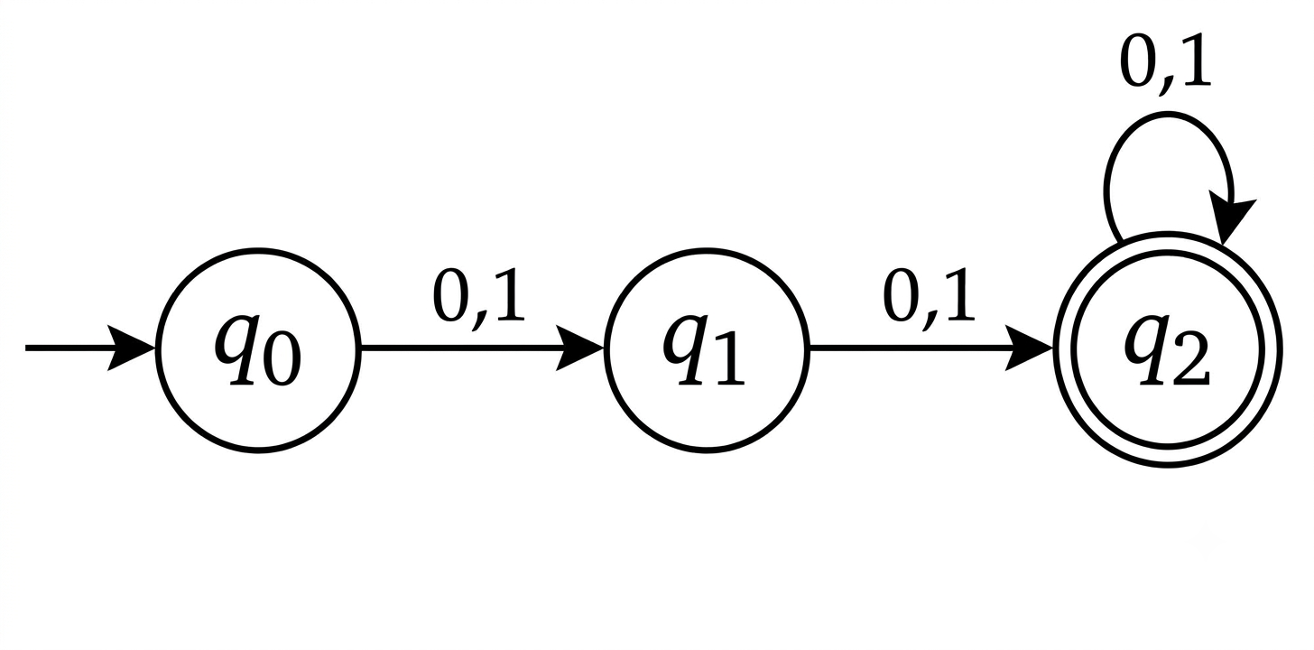q0 -(0,1)-> q1, q1 -(0,1)-> q2, q2 -(0,1)-> q1, q2 is the only final state.

Reasoning
Let x = (0+1) denote a single symbol from the alphabet {0,1}.
From q0, the very first symbol always moves the automaton to q1 (never directly to the final state). After that, every further symbol simply flips the current state between q1 and q2 (q1→q2 on x, and q2 →q1 on x). The string is accepted only when the automaton finishes in q2.
Tracing the walk after the first symbol: 1 more symbol → q2 (ACCEPT), 2 more symbols → q1 (reject), 3 more symbols → q2 (ACCEPT), and so on. So the string is accepted exactly when the total number of symbols read is even (2, 4, 6, …).
Regular Expression: R = ((0+1)(0+1))⁺
(equivalently, R = ((0+1)(0+1))* (0+1)(0+1) )
In words: the language consists of all strings over {0,1} whose length is even and at least 2 — i.e., all non-empty even-length binary strings.

Question 2 — Grammar Analysis
S → aSc | T | U | ε

(A) Language defined by the grammar
Unrolling each nonterminal:
T generates bᵐcᵐ for m ≥ 0 (equal b's followed by equal c's)
U generates aᵏbᵏ for k ≥ 0 (equal a's followed by equal b's)
S wraps n copies of the rule S → aSc around one final choice of ε, T, or U, i.e. S ⇒ aⁿ (ε | T | U) cⁿ for n ≥ 0.
This gives three families of strings, which combine into two general patterns (the ε-case is a special case of both):
• Using T: aⁿbᵐc^{n+m}aⁱbʲcᵏ with k = i + j
• Using U: a^{n+k}bᵏcⁿ — i.e. strings aⁱbʲcᵏ with i = j + k
L(S) = { aⁱ bʲ cᵏ : i,j,k ≥ 0 and (k = i+j OR i = j+k) }

(B) Derivation tree for aaabbc
aaabbc has i = 3 a's, j = 2 b's, k = 1 c. Check the two conditions: k = i+j → 1 = 5 (false); i = j+k → 3 = 2+1 = 3 (true). So the string belongs to the U-branch, with n = k(count of c) = 1 and k(U-recursion depth) = 2.
Leftmost derivation:
Derivation tree (indentation shows parent → children):
Reading the leaves left to right gives a · a · a · b · b · c = aaabbc, as required.

(C) Is the grammar ambiguous?
Yes, the grammar is ambiguous. A grammar is ambiguous if some string in its language has two distinct derivation trees (or leftmost derivations).
Example — the string "ac":
Derivation 1 (via T, with m = 0): S ⇒ aSc ⇒ aTc ⇒ a·ε·c = ac
Derivation 2 (via U, with k = 0): S ⇒ aSc ⇒ aUc ⇒ a·ε·c = ac
These are two structurally different parse trees (one branches through T, the other through U) that both yield the same terminal string "ac". Hence the grammar is ambiguous.
(As a further, even simpler witness: the empty string ε has three separate parse trees — S ⇒ ε directly, S ⇒ T ⇒ ε, and S ⇒ U ⇒ ε.)

Question 3 — ε-NFA for 00*1 + 11*0
Split the expression into its two alternatives and build each with Thompson's construction, then join them with a new start state and a new final state using ε-transitions.
r1 = 0 0* 1 → states p0, p1, p2 (p2 final for r1)
r2 = 1 1* 0 → states q0, q1, q2 (q2 final for r2)
Transition table
State | 0 | 1 | ε
S (start) | - | - | p0 , q0
p0 | p1 | - | -
p1 | p1 | p2 | -
p2 | - | - | F
q0 | - | q1 | -
q1 | q2 | q1 | -
q2 | - | - | F
F (final) | - | - | -

Every string derivable from 0 0*1 reaches p2 → F via ε, and every string derivable from 1 1*0 reaches q2 → F via ε, so L(ε-NFA) = 00*1 + 11*0, exactly as required.

Question 4

(I) If L1 and L2 are regular, then L1 ∪ L2 is regular
Proof (by product construction):
Since L1 and L2 are regular, there exist DFAs

Construct a new DFA M = (Q, Σ, δ, s, F), where:
Q = Q1 × Q2 (each state is a pair (r,s), one component tracking M1, the other tracking M2)

F = { (r,s) ∈ Q : r ∈ F1 OR s ∈ F2 } (accept if either simulated machine would accept)
By induction on the length of an input string w, one shows M reaches state (δ1*(s1,w), δ2*(s2,w)) after reading w. Hence M accepts w ⇔ δ1*(s1,w) ∈ F1 or δ2*(s2,w) ∈ F2 ⇔ w ∈ L1 or w ∈ L2. Therefore L(M) = L1 ∪ L2.
Since M is a finite-state DFA (with |Q1|·|Q2| states), L1 ∪ L2 is accepted by a DFA and is therefore regular. ∎
(Equivalent shorter argument: if r1, r2 are regular expressions for L1, L2, then r1 + r2 is a regular expression for L1 ∪ L2 by definition of regular expressions, so L1 ∪ L2 is regular.)

(II) Is L = { aᵖ : p is prime } regular?
No — L is not regular. We prove this using the Pumping Lemma for regular languages.
Suppose, for contradiction, that L is regular. Let n be the pumping length guaranteed by the pumping lemma.
Since there are infinitely many primes, choose a prime p ≥ n. Let w = aᵖ, so |w| = p ≥ n. By the pumping lemma, w = xyz with |xy| ≤ n, |y| ≥ 1, and xyⁱz ∈ L for every i ≥ 0.
Let |y| = k where 1 ≤ k ≤ n. Then |xyⁱz| = p + (i-1)k.
Choose i = p + 1. Then:
|xy^{p+1}z| = p + p·k = p(1 + k)
This number is composite: it has p ≥ 2 as a factor and the other factor (1+k) ≥ 2 (since k ≥ 1), so p(1+k) is not prime.
Hence xy^{p+1}z = a^{p(1+k)} ∉ L, contradicting the pumping lemma (which requires xyⁱz ∈ L for all i ≥ 0).
This contradiction shows the assumption is false. Therefore L = { aᵖ : p is prime } is not regular. ∎

Question 5 — DFA Minimization

Given DFA
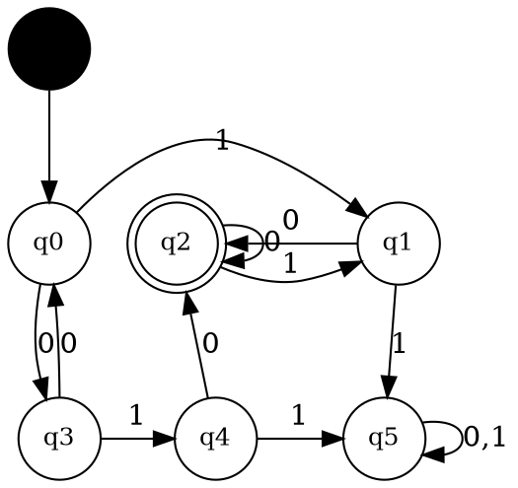

States: q0 (start), q1, q2 (final), q3, q4, q5. Transition table:
State | 0 | 1
→ q0 | q3 | q1
q1 | q2 | q5
q2 (final) | q2 | q1
q3 | q0 | q4
q4 | q2 | q5
q5 | q5 | q5

Step 1 — Initial partition
P0 = { Non-final, Final } = { {q0,q1,q3,q4,q5} , {q2} }

Step 2 — Refine using transition destinations
Classify each non-final state by the partition-class its 0- and 1-transitions land in:
State | on 0 → class | on 1 → class | Signature
q0 | q3 (NF) | q1 (NF) | (NF,NF)
q1 | q2 (F) | q5 (NF) | (F,NF)
q3 | q0 (NF) | q4 (NF) | (NF,NF)
q4 | q2 (F) | q5 (NF) | (F,NF)
q5 | q5 (NF) | q5 (NF) | (NF,NF)

P1 = { {q0,q3,q5} , {q1,q4} , {q2} }

Step 3 — Refine again
Within {q0,q3,q5}, check destinations against the new classes A={q0,q3,q5}, B={q1,q4}, C={q2}:
State | on 0 | on 1 | Signature
q0 | q3 (A) | q1 (B) | (A,B)
q3 | q0 (A) | q4 (B) | (A,B)
q5 | q5 (A) | q5 (A) | (A,A)

q5's signature (A,A) differs from q0, q3's signature (A,B) — so q5 splits off. Checking {q1,q4} against the classes shows both have signature (C,A) — they stay merged.
P2 = { {q0,q3} , {q1,q4} , {q5} , {q2} }

Step 4 — Verify stability
Re-checking {q0,q3} and {q1,q4} against P2's classes gives identical signatures within each group (shown below), so no further splitting occurs — the partition is stable.
Final equivalence classes: A = {q0,q3}, B = {q1,q4}, C = {q2}, D = {q5}

Minimized transition table (A is the start state, C is the only final state):
State | 0 | 1
→ A {q0,q3} | A | B
B {q1,q4} | C | D
C {q2} (final) | C | B
D {q5} | D | D

The minimized automaton has 4 states (down from 6): A = {q0,q3}, B = {q1,q4}, C = {q2} (final), D = {q5}, with A as the start state and C as the only final state, as shown in the diagram above.

